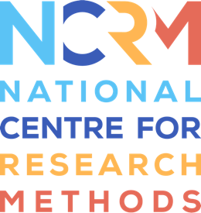
Reanimating Data Method

Transcript
https://www.ncrm.ac.uk/resources/online/all/?id=20804

Reasking:
When working with interview transcripts our first impulse may be to look at what people have to say, but an easy and more sideways route into the archive can be to explore what people were asked.
Questions can be revealing in all sorts of ways; they can also connect us directly and personally to the material. How would we answer that question?

Collaging:
Archive documents can be used as raw materials for creative work. At the simplest level, we can invite participants to chop up transcripts and to create poems, face-to-face or digitally. Juxtaposing images and texts in new ways can be a starting point for conversations, for example, we can use collage to explore social continuity and change.

Revoicing:
By revoicing the words of participants we can step into their shoes. We can experiment with the different meanings that their phrases evoke, and we can reflect on the experience of doing this; speaking back
to research participants and finding connections over time and space, perhaps recalling our younger selves in the process.

Recollecting:
Encountering and engaging with stories discovered in the archive can be inspiring. People may find they want to tell their own stories and to collect the stories of others to build an archive for the future.

An archive can take many forms: experiences collected together in a Pinata, messages stitched together in a banner. It could be a digital archive where we're invited to upload our own personal collection of memorable objects.
Collecting and being collected is a project that can be shared.

National Centre for Research Methods (NCRM)
Social Sciences
Murray Building (Bldg 58)
University of Southampton
Southampton SO17 1BJ
United Kingdom
Web www.ncrm.ac.uk
Email info@ncrm.ac.uk
Tel +44 23 8059 4539
Twitter @NCRMUK

